Southeastern MA (SEMA) Public Health Collaborative
FY26 Year-End Impact Report
July 1, 2025 – June 30, 2026

Prepared by Gina Mucciardi, MPH
Public Health Excellence Shared Services Coordinator & Data Analyst

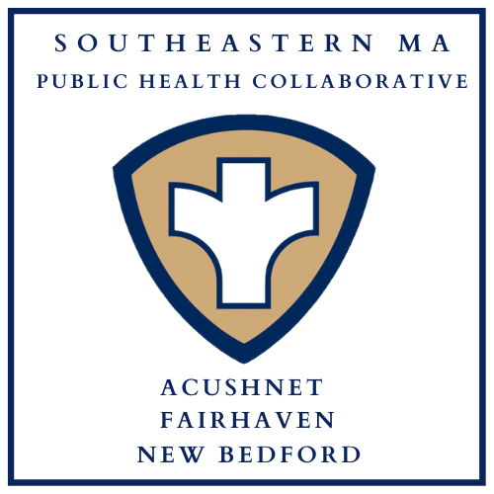

Table of Contents

Background: The Public Health Excellence (PHE) Grant Program 3
Public Health Nursing 4
Public Health Nursing Clinics 4
In-Home Vaccination Program 5
Lifesaving Skills Trainings 5
Health Education 6
Car Seat Safety Checks & Distribution Program 6
Community Outreach 7
Infectious Disease Case Investigation 7
Tuberculosis Case Management 7
Community Resources Available for Distribution 7
Community Sunscreen Dispensers 8
Environmental Health 9
Health Communications 10
Car Seat Safety Campaign 10
Website and Social Media 10
Conclusion 11
Appendix A: Staffing Chart 12

Background: The Public Health Excellence (PHE) Grant Program
In 2021, the New Bedford Health Department applied and was awarded grant funding by the Massachusetts Department of Public Health (DPH) to lead a shared services arrangement of the Acushnet, Fairhaven, and New Bedford Health Departments following the recommendations of the Blueprint for Public Health Excellence. In the 2019 Blueprint report, cross-jurisdictional sharing of public health services was named as an evidence-based strategy to enhance the efficiency and effectiveness of local public health in Massachusetts. An intermunicipal agreement was established to share health services among the communities, and the partnership became known as the Southeastern Massachusetts Public Health Collaborative, or SEMA Public Health.
SEMA Public Health is now in its fourth year and is fully staffed with 4.25 FTE grant-funded public health professionals who facilitate and provide services in Acushnet, Fairhaven, and New Bedford. The goals of the PHE shared services grant program have been codified into Massachusetts state law via the SAPHE Act of 2020, and further in the SAPHE 2.0 Act of 2024. The following report summarizes the activities conducted during the first three quarters of FY26 to demonstrate the value and shared benefits of the SEMA Public Health collaborative to the communities of Acushnet, Fairhaven, and New Bedford.
With the SEMA Public Health partnership, nursing services have been established where none previously existed; Two full-time public health nurses and one part-time community health worker conduct infectious disease control activities and a myriad of public health nursing services. Shared staff provide language capacity in Portuguese and Cape Verdean Creole; Support and backup for environmental health inspections that was once severely needed now exists with a regional shared inspector. The collaborative’s coordinator/data analyst facilitates the execution of the shared services program, liaising with municipal health leadership, DPH, and an ever-increasing number of community partners.
Thanks to the PHE grant program, this group effectively strengthens the capacity and quality of public health protections in Acushnet, Fairhaven, and New Bedford without utilizing municipal budgets and local taxpayer dollars. The work of SEMA Public Health falls into three major categories that inform the organization of this report: Public Health Nursing, Environmental Health, and Health Communications.
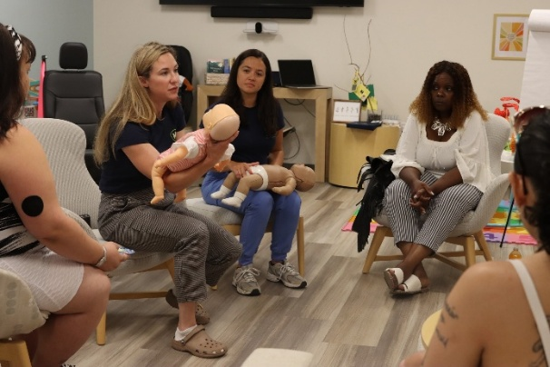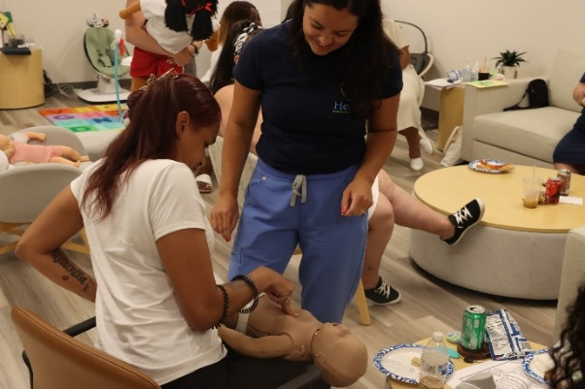

Public Health Nursing
The public health nursing team includes two registered nurses and one community health worker. Together, their services include clinics (community wellness, vaccine, and tuberculosis skin testing), lifesaving skills trainings, car seat safety checks and distribution, in-home vaccinations, infectious disease case investigation, tuberculosis case management, and community outreach. All materials promoting these services are advertised in each municipality and when a service is offered in another language, translated.

Public Health Nursing Clinics
Three types of clinics are offered by the public health nursing division:
- Community Wellness Clinics – Conducted on-site in community spaces, these clinics offer blood pressure screening, health education, naloxone training and distribution, car seat safety checks, and community resource distribution. For the full list of resources available for distribution, see page 7.

- Vaccine Clinics – Public health nurses administer seasonal influenza vaccines, both standard and high-dose, for insured and uninsured individuals age 18 and over, as well as tetanus vaccines for uninsured individuals via community clinics and in-home for homebound individuals.

- Tuberculosis (TB) Skin Test Clinics- Individuals may need a TB skin test for screening purposes, such as for work, school enrollment, or immigration requirements. Weekly TB clinics are offered at the New Bedford Health Department with subsequent reporting/referral taking place for any individual with a positive skin test result.

Nursing Clinic Totals
Clinic Type | Q4 Attendance | Q4 Clinic Count | FY26 Total Attendance | FY26 Total Clinic Count
Flu Vaccine | 2 | 1 | 236 | 21
Community Wellness | 120 | 12 | 313 | 38
Tuberculosis Skin Test | 23 | 6 | 148 | 36
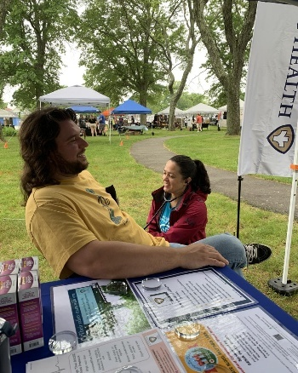
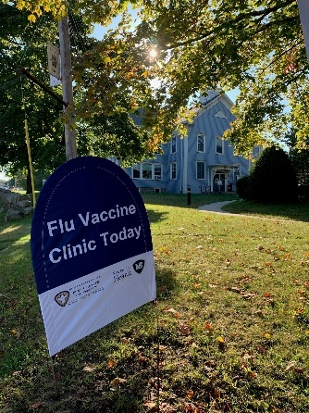
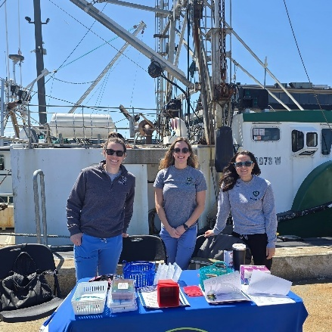

In-Home Vaccination Program
SEMA Public Health advertises and offers no-cost, in-home flu vaccinations for adults in New Bedford, Fairhaven, and Acushnet who may otherwise have difficulty getting to a community vaccination location. During FY

Total In-Home Vaccines Administered
48

Lifesaving Skills Trainings
Lifesaving skills training courses offered by SEMA Public Health include:
- Heartsaver CPR, AED, & First Aid with Narcan: Hands-on, in-person training with certification provided through the American Heart Association. Narcan training is included with all Heartsaver courses taught by SEMA.

  - Narcan (naloxone): Equips individuals to recognize the signs of an overdose and to administer Narcan (naloxone) effectively during emergencies.

- Stop the Bleed – Prepares anyone with little or no medical training to recognize and control life-threatening bleeding before professional help arrives.

- Safe Start Baby Safety Classes – Prepares caregivers with education about safe sleep and hands-on training for infant CPR, choking, and car seat safety.

- Youth Mental Health First Aid – Empowers adults with skills to recognize, understand, and confidently respond to mental health and substance use challenges in youth age 12-18.

- Safe@Home by SafeSitter® – Prepares youth age 9-12 to care for themselves when parents are away for a short period of time.

- New! SafeSitter® Essentials with CPR – Trains students age 13-15 to look after younger children when adults are not home.

Lifesaving Skills Training Totals
Training | Individuals Trained in Q4 | Total Trained FY2026
Heartsaver CPR, AED, First Aid & Narcan | 56 | 133
Stop the Bleed | 0 | 51
Safe Start (Baby Safety) | 0 | 25
Youth Mental Health First Aid | 54 | 100
Safe@Home by SafeSitter® | 0 | 6
SafeSitter® Essentials with CPR | 14 | 14

Health Education
This spring, SEMA Public Health nurses provided health education to teen parents enrolled in the New Bedford Public Schools Parenting Teens Program, where they taught adult, child, and infant CPR and choking response, as well as car seat safety.

Car Seat Safety Checks & Distribution Program
The SEMA Public Health nursing team (nurses and community health worker) are all certified Child Passenger Safety technicians with the National Highway Traffic Safety Administration (NHTSA) to provide hands-on, educational car seat safety checks to encourage proper use and adherence to state and national safety standards.

The New Bedford Health Department has a grant that provides car seats for local families in need. SEMA Public Health nursing team thus provides caregivers with car seats as well as education on proper installation and usage.

Car Seat Safety Program Summary
Service | Q4 | FY26 Total
Car Seat Safety Checks | 27 | 129
Car Seats Distributed | 26 | 114

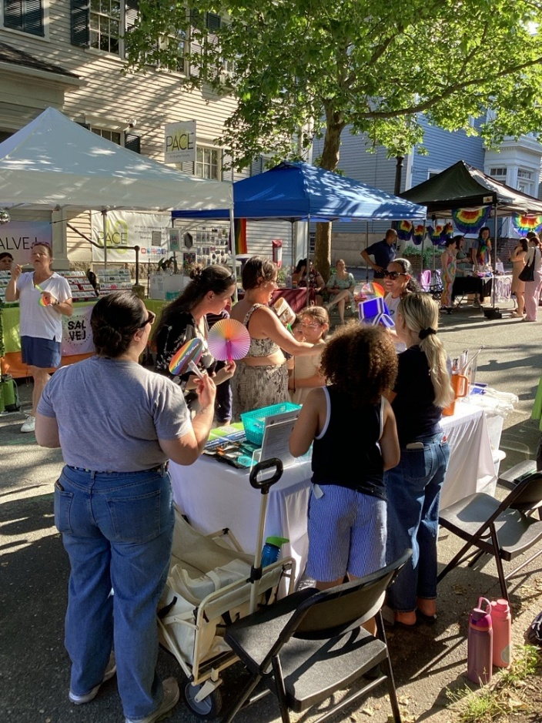
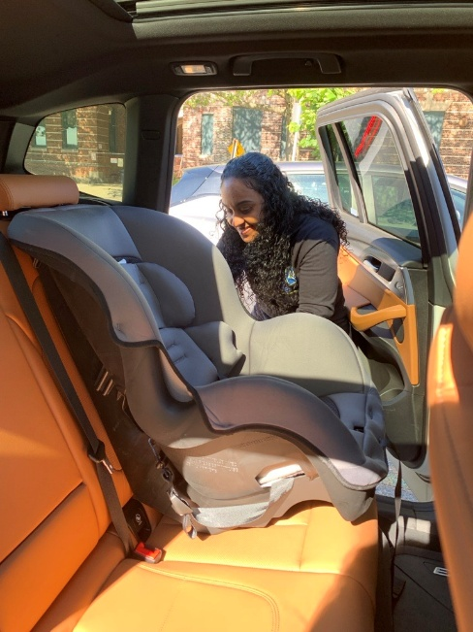

Community Outreach
Community outreach involves bringing education and resources directly to communities to improve overall population health and is often done in partnership with other community-serving organizations. In the summary below, individual touchpoints refer to the approximate number of individual engagements made by the SEMA Public Health team at community outreach events.

Community Outreach Totals
Q4 Touchpoints | Q4 Events | FY26 Total Touchpoints | FY26 Total Events
1,955 | 15 | 4,268 | 46

Infectious Disease Case Investigation
The SEMA Public Health nursing team provides daily monitoring of the Massachusetts Virtual Epidemiological Network (MAVEN) in New Bedford and provides backup coverage in Acushnet and Fairhaven. Infectious disease case investigation is mandated by state law in the Massachusetts Code of Regulations 105 CMR 300.

Tuberculosis Case Management
SMEA Public Health’s registered nurses provide tuberculosis case management for individuals with active cases of the disease in New Bedford and backup case management in Acushnet and Fairhaven. Tuberculosis case management is mandated by state law in the Massachusetts Code of Regulations 105 CMR 365.

Community Resources Available for Distribution
The following health promotion resources have been made available to community members in New Bedford, Fairhaven, and Acushnet by the SEMA Public Health partnership. The following items were either donated or purchased with grant funds and are distributed to community members with information about SEMA Public Health and its services:
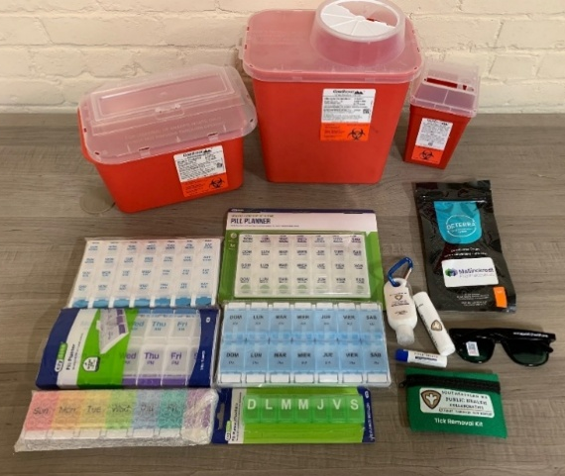
- Tick removal kits
- Bleeding emergency kits
- Drug deactivation and disposal pouches
- Medication organizers (in English & Spanish)
- Sharps containers
- SPF 30 individual sunscreen
- SPF 30 lip balm
- UV400 sunglasses
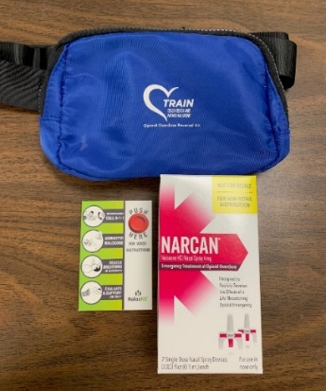
- Hand sanitizer
- CPR face shields
Additionally, Narcan (naloxone) kits are distributed to every individual who completes Narcan training. SEMA Public Health has increased community access to Narcan by expanding the reach of the New Bedford Health Department’s existing Narcan distribution program into the towns of Acushnet and Fairhaven.

Community Sunscreen Dispensers
SEMA Public Health’s community sunscreen dispensers are accessible during the summer months in key locations across participating municipalities with free SPF 30, reef-safe, sport sunscreen. An additional mobile sunscreen dispenser unit is brought to SEMA outreach events during the spring and summer months.
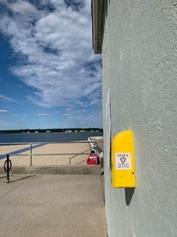 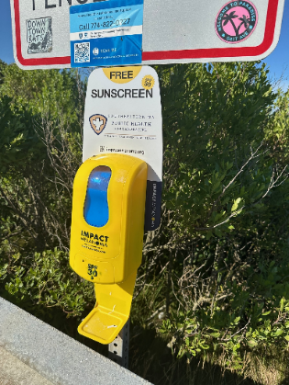 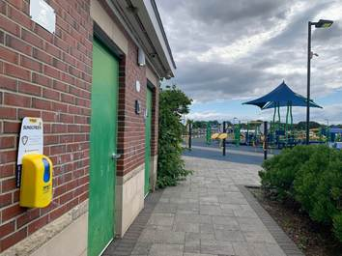 West Beach, New Bedford West Island, Fairhaven Noah’s Place Playground, Pope’s Island
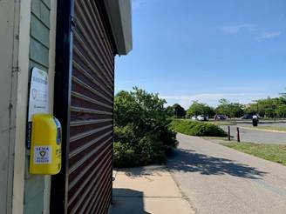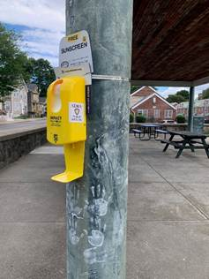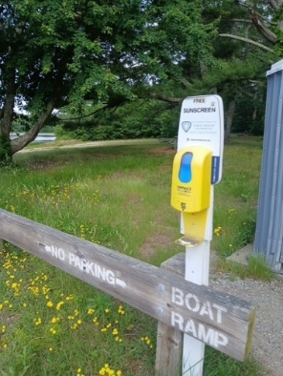
Fort Taber, New Bedford Monte Park, New Bedford Acushnet Sawmill

Environmental Health
The PHE Inspector is responsible for the following in each municipality:
- Acushnet: Conduct food inspections on a risk-based inspection schedule; conduct other environmental inspections as needed.
- Fairhaven: Conduct food inspections on risk-based inspection schedule; assist Health Department staff with transition to OpenGov; conduct beach water testing and other environmental inspections as needed.
- New Bedford: Train new employees; assist with internal operations including SOP creation, permitting, and process improvements; provide OpenGov technical support.

Environmental Health Inspections: FY26 Totals
 | Number of Inspections
Acushnet | 89
Fairhaven | 49
If a food establishment is facing possible shutdown due to repeated violations, the PHE Inspector conducts on-site restaurant employee training for risk mitigation.
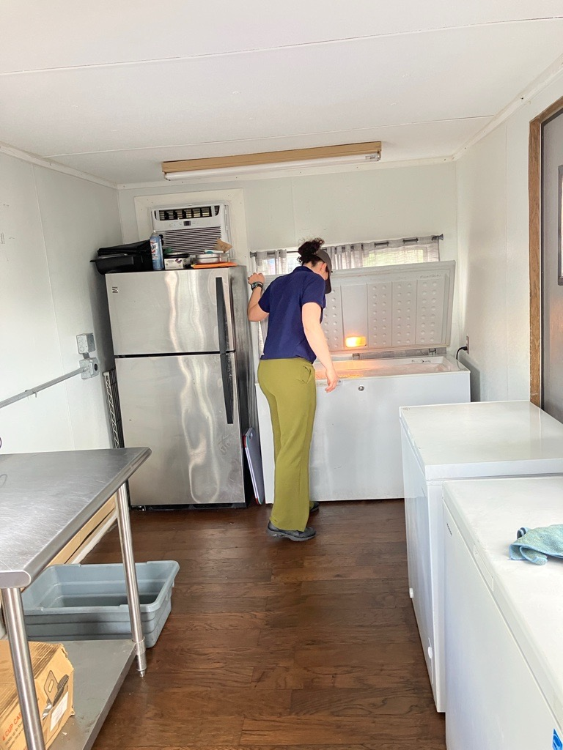

Health Communications

Car Seat Safety Campaign
During Summer 2025, SEMA Public Health launched a mass media campaign to promote car seat safety and advertise its car seat safety check service. The campaign included a billboard on Route 195 W in New Bedford and advertisements on 13 SRTA buses in English, Spanish, and Portuguese.
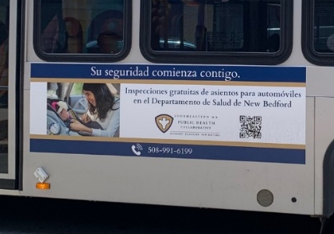
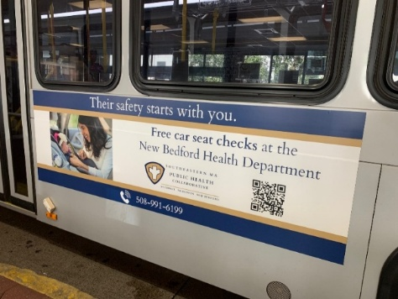
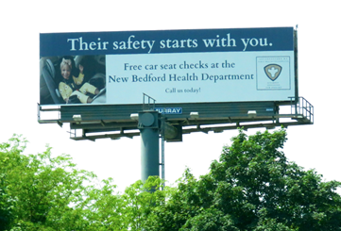

Website and Social Media
SEMA Public Health has a website, Facebook, and Instagram account that are regularly updated by the shared services coordinator. These outlets promote services and events put on by the collaborative and its partners and shares health messaging. Occasionally, SEMA Public Health will pay to advertise content to reach additional people in the region.
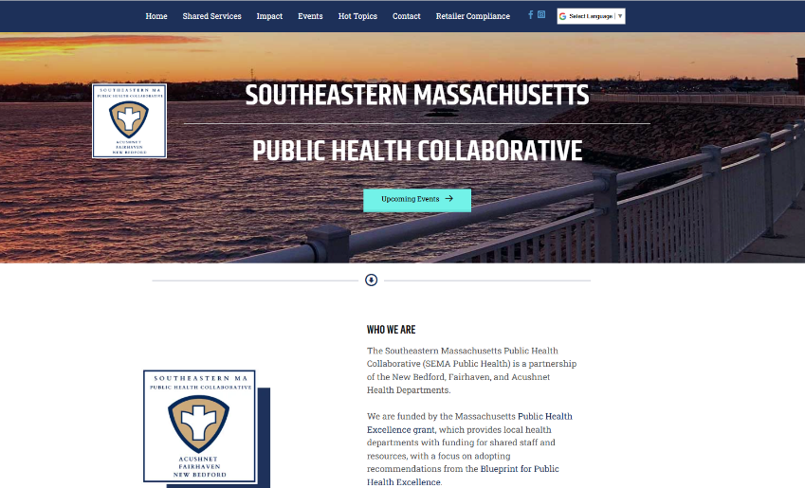
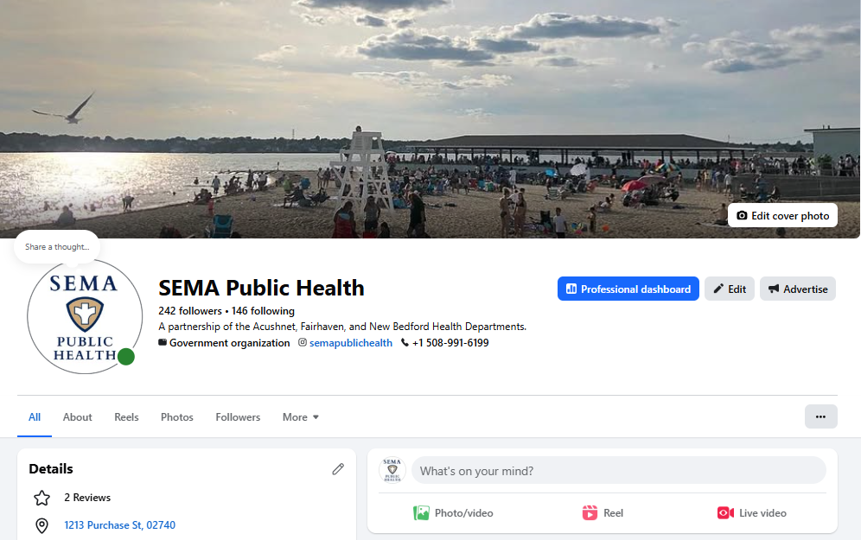

Conclusion
The SEMA Public Health partnership has established nursing services where none previously existed and offers a myriad of services that promote health and prevent harm. A shared environmental health inspector provides needed support, backup, and language capacity for environmental health inspections, and the shared services coordinator/data analyst keeps the work driving forward by identifying gaps and coordinating needed services.

Between July 1, 2025 and June 30, 2026, SEMA Public Health:
- Brought resources & health information to 4,269 people at 46 community events
- Hosted 95 clinics that reached 697 individuals
- Provided lifesaving skills training to 329 community members
- Distributed & installed 114 car seats to families in need & performed 129 total car seat safety checks
- Vaccinated 284 adults for influenza, including 48 vaccines administered in-home
- Provided direct community access to SPF 30 sunscreen at 17 recreational sites during the summer months
- Collaborated with 58 community partner organizations to provide services and resources
- Launched a multilingual mass media campaign to promote car seat safety
- Conducted 138 environmental health inspections across Acushnet & Fairhaven
- Provided expert-level training & mentorship to three new municipal health inspectors
- Provided food safety education for restaurant staff facing repeated violations

SEMA Public Health works with municipal health leadership and community partners to strengthen local public health service delivery in Acushnet, Fairhaven, and New Bedford efficiently and effectively thanks to grant funding from the Massachusetts Department of Public Health.
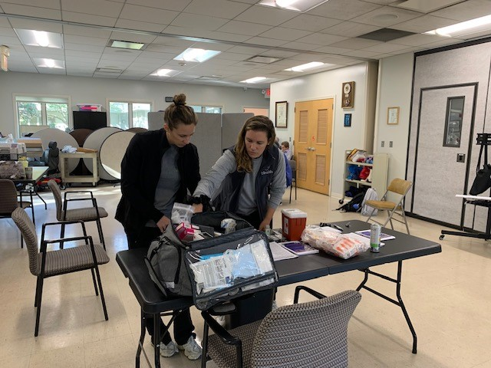

Appendix A: Staffing Chart
Staff Name & Title | FTE | Responsibilities
Gina Mucciardi, MPH  Shared Services Coordinator  & Data Analyst | 1.0 | Provides data-driven recommendations to support the design and implementation of program initiatives to improve local health outcomes; Coordinates, promotes, tracks, and reports on SEMA Public Health services and staff time; Convenes regular meetings with participating municipal health department heads and staff to advance the goals of the PHE grant program; Supports management of the grant budget; Conducts community outreach; Disseminates health communication messaging and manages the SEMA Public Health website and social media.
Kristy MacMillen, BSN, RN, CLC  PHE Nurse | 1.0 | Supports the design and implementation of program initiatives to improve local health outcomes; Conducts trainings including Heartsaver CPR & AED, naloxone, Stop the Bleed, baby safety classes, SafeSitter® and Safe at Home®; Conducts blood pressure screenings, tuberculosis skin tests, and car seat safety checks; Administers vaccines at community clinics and for homebound individuals; Conducts community outreach; Creates messaging to be used in health communication initiatives; Provides case management for individuals with active tuberculosis (TB) and conducts backup infectious disease case investigation in MAVEN as necessary.
Ashley Correia, BSN, RN  PHE Nurse | 1.0 | Supports the design and implementation of program initiatives to improve local health outcomes; Conducts trainings including Heartsaver CPR & AED, naloxone, Stop the Bleed, Youth Mental Health First Aid, baby safety classes, SafeSitter® and Safe at Home®; Conducts blood pressure screenings, tuberculosis skin tests, and car seat safety checks; Administers vaccines at community clinics and for homebound individuals; Conducts community outreach; Creates messaging to be used in health communication initiatives; Provides case management for individuals with active tuberculosis (TB) and conducts backup infectious disease case investigation in MAVEN as necessary.
Sofia DaCosta, RS  PHE Inspector | 1.0 | Acushnet & Fairhaven: Conducts environmental health inspections; Assists in the standardization forms and processes; Trains new municipal staff; Prepares regulations for presentation to respective boards of health; Conducts risk-mitigation education outreach.  New Bedford: Trains new municipal staff; Assists with internal operations, including permit processing, process improvements, and the standardization of forms and procedures; Provides technology support for OpenGov.
Rosa Matos, CCHW  Community Health Worker | 0.25 | Acushnet & Fairhaven: Conducts community outreach, car seat safety checks, and blood pressure screenings at clinics and community events.  New Bedford: Monitors MAVEN and conducts infectious disease case investigations as necessary; Provides Directly Observed Therapy (DOT) for patients with active tuberculosis; Conducts community outreach; Provides car seat safety checks and blood pressure screenings.

Appendix B: Community Partners
During FY26, SEMA Public Health collaborated with 58 community partners to provide public health services and resources. Partner organizations include:
Acushnet Board of Health
Acushnet Council on Aging
Acushnet Housing Authority
AHA! New Bedford
Apple-Peach Festival
ASPIRE Program
Buttonwood Park Zoo
Buttonwood Senior Center
Cape Verdean Recognition Committee of New Bedford
Casey Miller Apartments
Discover Fairhaven
Fairhaven Belonging Committee
Fairhaven Council on Aging
Fairhaven Fire Department
Fairhaven Health Department
Fairhaven High School
Fairhaven Housing Authority
Fairhaven Police Department
Fairhaven Recreation Center
Fairhaven Village Apartments
Fishing Partnership Support Services
The Gallery Bar
Greater New Bedford Allies for Health and Wellness
Greater New Bedford Opioid Task Force
Hand-Up Mattress Company
Kennedy Donovan Center
Little Explorers Day Care
Massachusetts Department of Children & Families
MassHire of Greater New Bedford
Massachusetts Society for the Prevention of Cruelty to Children
Millicent Library
New Bedford Community Health
New Bedford Farmer’s Market
New Bedford Free Public Library
New Bedford Health Department
New Bedford Housing Authority
New Bedford Parks, Recreation, & Beaches Department
New Bedford Public Schools
New Beginnings Moms Do Care Program
Normandin Middle School
Northstar Learning Centers
Olympia Towers
Our Sister’s School
Positive Action Against Chemical Addiction (PAACA)
People Acting in Community Endeavors (PACE)
Pinnacle Auto Sales
Project Independence
Rise up for Homes
Safe & Successful Youth Initiative (SSYI)
The Shannon Program
Southcoast Health (including St. Luke’s Hospital and Southcoast Obstetrics & Gynecology)
Southcoast LGBTQ+ Network
Southeast Network of Community Health Workers
St. Anthony of Padua Church
United Way Family Resource Center
United Way of Greater New Bedford
Whaling City Festival
YMCA Southcoast

