Southeastern MA (SEMA) Public Health Collaborative
FY26 Q1-Q2 Impact Report
July 1, 2025 – December 31, 2025

Prepared by Gina Mucciardi, MPH
Public Health Excellence Shared Services Coordinator & Data Analyst

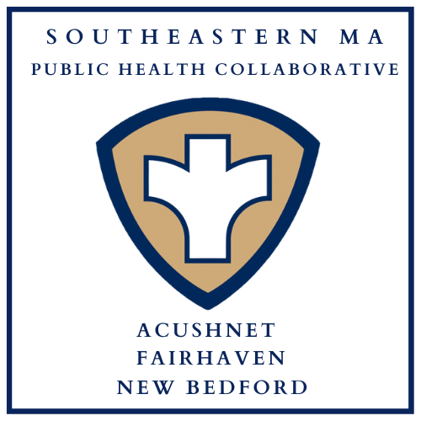

Table of Contents

Background: The Public Health Excellence (PHE) Grant Program 3
Public Health Nursing 4
Public Health Nursing Clinics 4
Q1-Q2 Clinic Totals 4
In-Home Vaccination Program 5
Lifesaving Skills Trainings 5
Car Seat Safety Checks & Distribution Program 6
Community Outreach 6
Infectious Disease Case Investigation 7
Tuberculosis Case Management 7
Blood Drives 7
Community Resources Available for Distribution 7
Community Sunscreen Dispensers 8
Environmental Health 9
Health Communications 10
Car Seat Safety Campaign 10
Website and Social Media 10
Conclusion 11
Appendix A: Staffing Chart 12
Appendix B: Community Partners 13

Background: The Public Health Excellence (PHE) Grant Program
In 2021, the New Bedford Health Department applied and was awarded grant funding by the Massachusetts Department of Public Health (MDPH) to lead a shared services arrangement comprised of Acushnet, Fairhaven, and New Bedford following the recommendations of the 2019 Blueprint for Public Health Excellence which named cross-jurisdictional sharing of public health services as an evidence-based strategy to enhance the efficiency and effectiveness of local public health in Massachusetts. These three municipalities entered into an intermunicipal agreement and became established as the Southeastern Massachusetts Public Health Collaborative, also known as SEMA Public Health.
The SEMA Public Health collaborative is now in its third year and is fully staffed with 4.25 FTE grant-funded public health professionals who facilitate and provide services in Acushnet, Fairhaven, and New Bedford. The goals of the PHE shared services grant program have been codified into Massachusetts state law via the SAPHE Act of 2020, and further in the SAPHE 2.0 Act of 2024. This report covers activities conducted during the first half of FY26 to demonstrate shared benefits and impact of the Southeastern Massachusetts Public Health Collaborative to participating municipalities.
With the SEMA Public Health Collaborative, nursing services have been established where none previously existed; Two full-time public health nurses and a part-time community health worker now provide backup infectious disease case investigation coverage and a myriad of nursing services have been developed and implemented; Shared staff provide language capacity in Portuguese and Cape Verdean Creole; Support and backup for environmental health inspections that was once severely needed now exists; The shared services coordinator/data analyst facilitates the execution of the shared services program in collaboration with municipal health leadership, the Massachusetts Department of Public Health, and community partners.
Together, this group effectively strengthens the quality and capacity of public health protections in Acushnet, Fairhaven, and New Bedford without utilizing municipal budgets and local taxpayer dollars.
Activities: The work of the Southeastern MA Public Health Collaborative falls into three major categories that inform the organization of this report: Public Health Nursing, Environmental Health, and Health Communications.
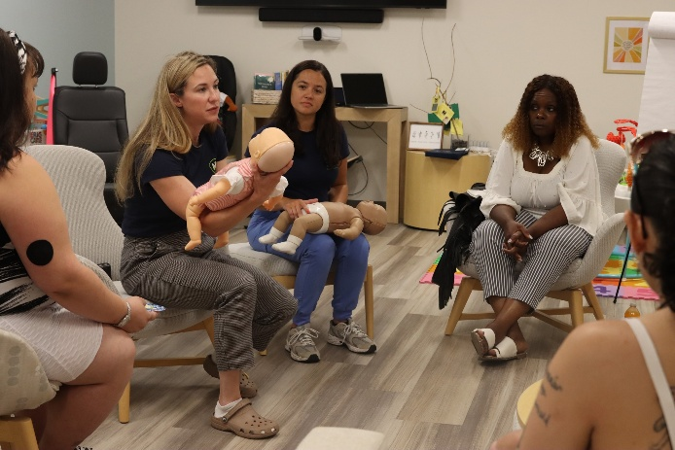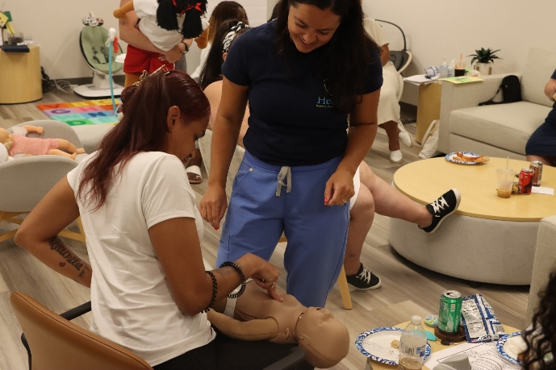

Public Health Nursing
The public health nursing team includes two registered nurses and one community health worker. Their services include clinics (community wellness, vaccine, and tuberculosis skin testing), lifesaving skills trainings, car seat safety checks and distribution, in-home vaccinations, infectious disease case investigation, tuberculosis case management, and community outreach. All materials promoting these services are advertised in each municipality and translated into the top three languages spoken by the communities.

Public Health Nursing Clinics
Three types of clinics are offered by the public health nursing division:
- Community Wellness Clinics – Conducted on-site in community spaces, these clinics offer blood pressure screening, health education, naloxone training and distribution, car seat safety checks, and community resource distribution. For the full list of resources available for distribution, see page 7.

- Vaccine Clinics – Public health nurses administer seasonal influenza vaccines, both standard and high-dose, for insured and uninsured individuals age 18 and over, as well as tetanus vaccines for uninsured individuals via community clinics and in-home for homebound individuals.

- Tuberculosis (TB) Skin Test Clinics- Individuals may need a TB skin test for screening purposes, such as for work, school enrollment, or immigration requirements. Weekly TB clinics are offered at the New Bedford Health Department with subsequent reporting/referral taking place for any individual with a positive skin test result.

Q1-Q2 Clinic Totals
- 97 Tuberculosis (TB) skin tests administered at 25 TB clinics
- 241 Flu vaccines administered at 18 flu clinics
- 86 Community members served at 13 community wellness clinics
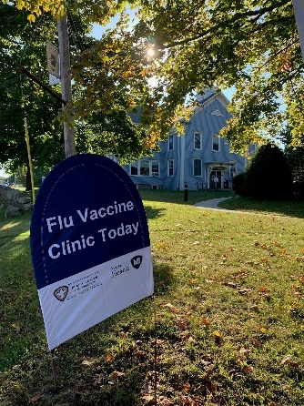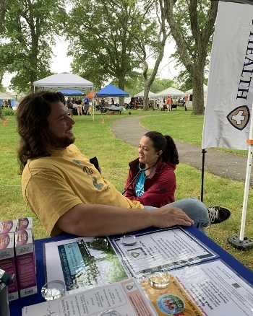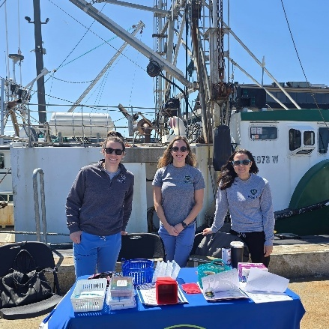

In-Home Vaccination Program
SEMA Public Health advertises and offers no-cost, in-home flu vaccinations for adults in New Bedford, Fairhaven, and Acushnet who may otherwise have difficulty getting to a community vaccination location.
- 41 In-home flu vaccines administered during the 2025 flu season

Lifesaving Skills Trainings
Lifesaving skills training courses offered by SEMA Public Health include:
- Heartsaver CPR, AED, & First Aid with Narcan: Hands-on, in-person training with certification provided through the American Heart Association. Narcan training is included with all Heartsaver courses taught by SEMA.

- Narcan (naloxone): Equips individuals to recognize the signs of an overdose and to administer Narcan (naloxone) effectively during emergencies.

- Stop the Bleed – Prepares anyone with little or no medical training to recognize and control life-threatening bleeding before professional help arrives.

- Safe Start Baby Safety Classes – Prepares caregivers with education about safe sleep and hands-on training for infant CPR, choking, and car seat safety.

Q1-Q2 Lifesaving Skills Training Totals
- Heartsaver CPR, AED, First Aid & Narcan: 64 people trained
- Narcan: 104 people trained
- Stop the Bleed: 38 people trained
- Safe Start: 16 people trained
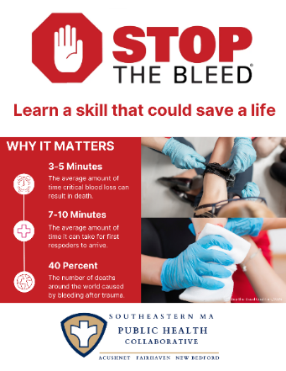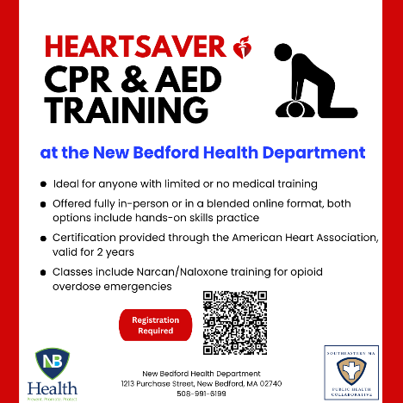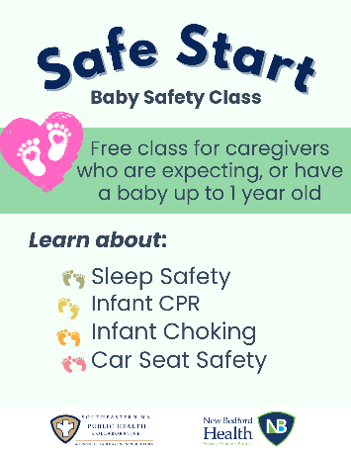

Car Seat Safety Checks & Distribution Program
The SEMA Public Health nursing team are certified Child Passenger Safety technicians with the National Highway Traffic Safety Administration (NHTSA) and provide hands-on, educational car seat safety checks to encourage proper use and adherence to state and national safety standards.
The New Bedford Health Department holds a state grant that provides car seats to low-income families in the region. The SEMA Public Health nursing team thus provides caregivers with car seats as well as education on proper installation and usage.

Q1-Q2 Car Seat Safety Program Summary
- 77 Safety checks performed
- 64 Car seats distributed
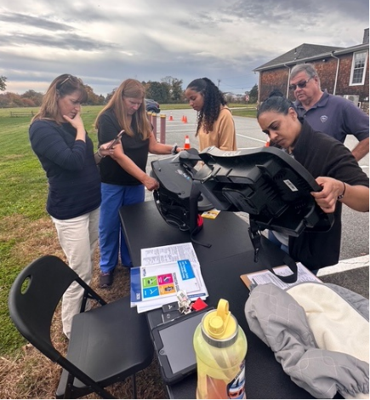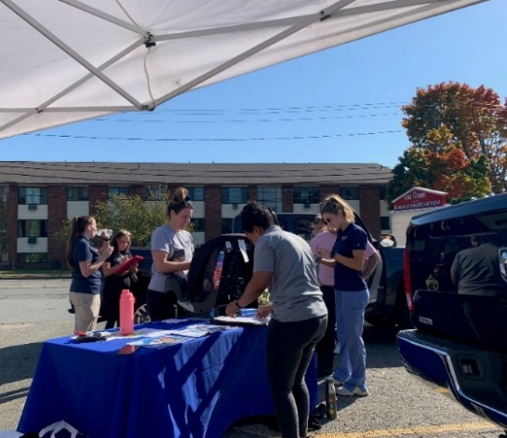

Community Outreach
Public health community outreach involves bringing education and resources directly to communities to improve overall population health and is often done in partnership with other community-serving organizations. In the summary below, ‘Touchpoints’ are the approximate number of individual engagements made by the SEMA Public Health team at community outreach events.

Q1-Q2 Community Outreach Summary
- 26 events attended
- 2,205 individual touchpoints made
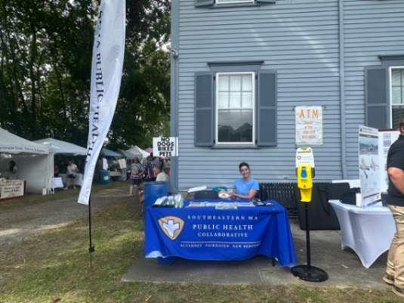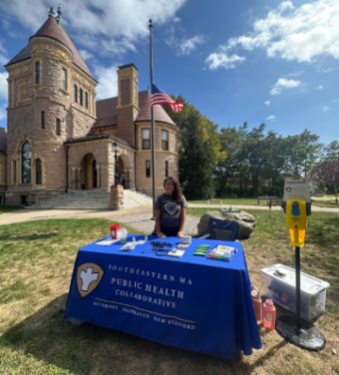

Infectious Disease Case Investigation
The SEMA Public Health nursing team provides daily monitoring of the Massachusetts Virtual Epidemiological Network (MAVEN) in New Bedford and provides backup coverage in Acushnet and Fairhaven. Infectious disease case investigation is mandated by state law in the Massachusetts Code of Regulations 105 CMR 300.

Tuberculosis Case Management
SMEA Public Health’s registered nurses provide tuberculosis case management for individuals with active cases of the disease in New Bedford and backup case management in Acushnet and Fairhaven. Tuberculosis case management is mandated by state law in the Massachusetts Code of Regulations 105 CMR 365.

Blood Drives
SEMA Public Health coordinated and hosted three American Red Cross blood drives in partnership with Southcoast Health in each participating shared services municipality. At each, the Southcoast Health Community Wellness Program offered point-of-care cholesterol and blood sugar (A1C) testing for blood donors and the general public.

2025 Blood Drive Totals
- 3 Blood drives conducted
- 47 pints of blood collected
- 141 patients in need potentially served
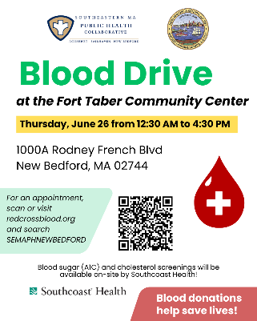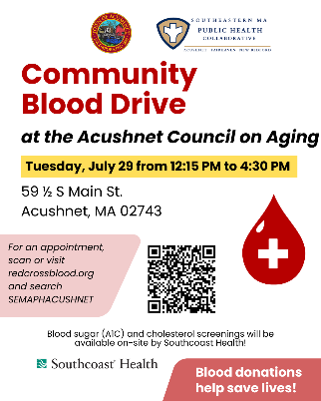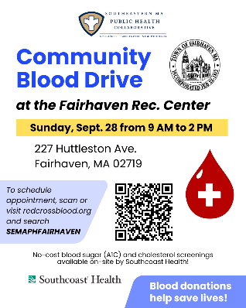

Community Resources Available for Distribution
During Q1 and Q2, the following health-promotion resources were made available for distribution by the SEMA Public Health partnership. These items were either purchased using grant funds or donated by local organizations. When possible, items are branded with the SEMA Public Health logo and website or given away with information advertising the SEMA Public Health collaborative and its services:
- Tick removal kits
- Bleeding emergency kits
- Deterra drug deactivation and disposal pouches
- Medication organizers (in English & Spanish)
- Sharps containers with town-specific sharps and medication disposal information
- SPF 30 individual sunscreen
- SPF 30 lip balm
- UV400 sunglasses
- Hand sanitizer
- CPR face shields
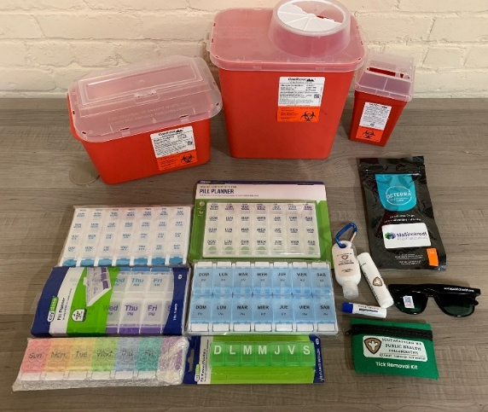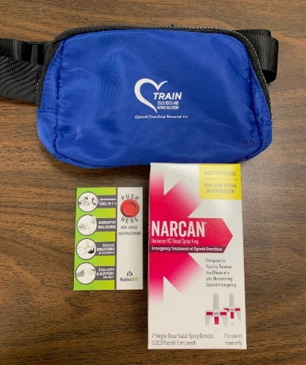
Additionally, Narcan (naloxone) kits were distributed after every Narcan training as well as to community members upon request during outreach events. The SEMA Public Health partnership has increased community access to Narcan by expanding the reach of the New Bedford Health Department’s existing Narcan program into the towns of Acushnet and Fairhaven.

Community Sunscreen Dispensers
SEMA Public Health’s community sunscreen dispensers are accessible during the summer months in key locations across New Bedford, Fairhaven, and Acushnet and provide free SPF 30, reef-safe, sport sunscreen to community members. An additional mobile sunscreen dispenser unit is brought to SEMA outreach events during the spring and summer months.
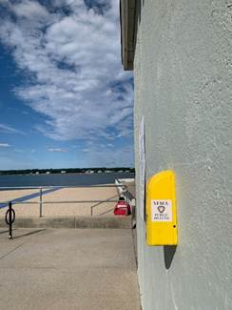 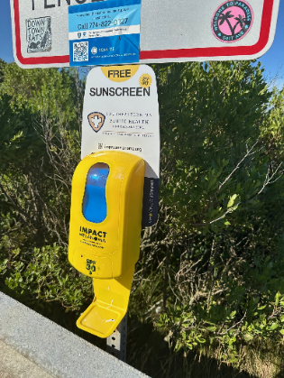 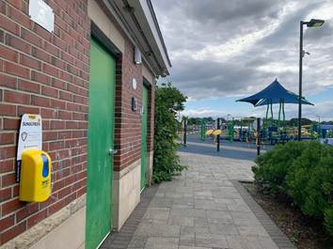 West Beach, New Bedford West Island, Fairhaven Noah’s Place Playground, Pope’s Island
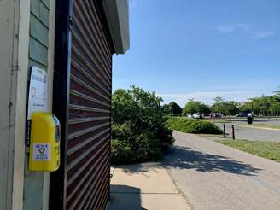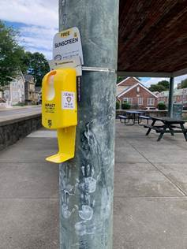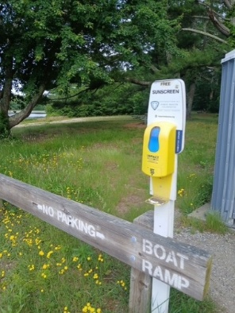
Fort Taber, New Bedford Monte Park, New Bedford Acushnet Sawmill

Environmental Health
The PHE Inspector is responsible for the following in each SEMA Public Health municipality:
- Acushnet: Conduct food inspections and transition the town to a risk-based food inspection schedule; conduct other environmental ad-hoc inspections as needed.
- Fairhaven: Conduct food inspections and transition the town to a risk-based food inspection schedule; assist Health Department staff with transition to OpenGov; conduct other environmental ad-hoc inspections as needed.
- New Bedford: Train new employees; assist with internal operations including SOP creation, process improvements; provide OpenGov technical support.

Q1-Q2 Environmental Health Inspections
Municipality | Number of Inspections | Time to Complete (Hours)
Acushnet | 14 | 22
Fairhaven | 7 | 10.5

If a food establishment is facing possible shutdown due to repeated violations, the PHE Inspector conducts on-site restaurant employee training for risk mitigation.
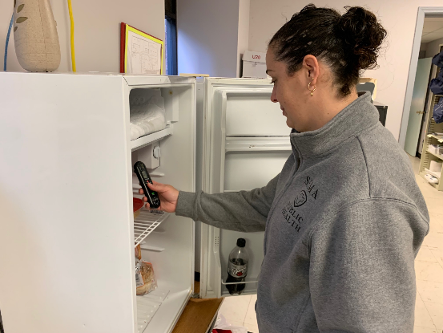

Health Communications

Car Seat Safety Campaign
SEMA Public Health launched a mass media campaign to promote car seat safety and advertise its car seat safety check service. The campaign included a billboard on Route 195 W in New Bedford and advertisements on 13 SRTA buses in English, Spanish, and Portuguese.
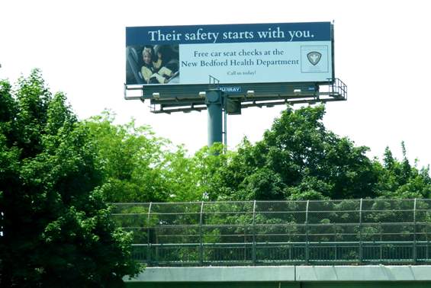
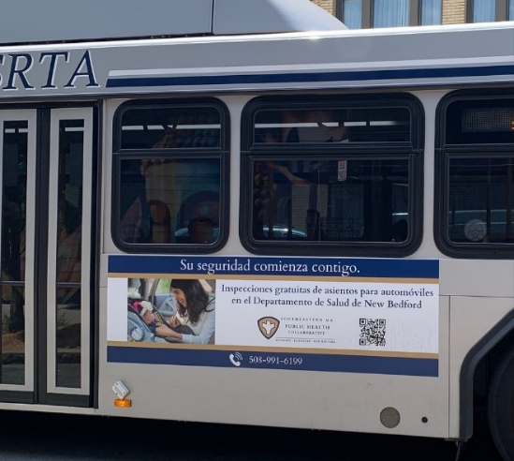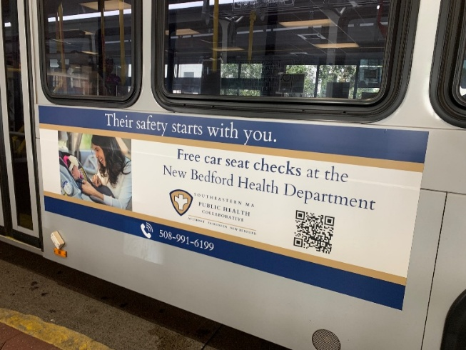

Website and Social Media
SEMA Public Health has a website, Facebook, and Instagram account that are regularly updated and monitored by the shared services coordinator. These outlets promote services and events put on by the collaborative and its partners and share messaging that aims to promote and protect health. Occasionally, SEMA pays to advertise content to reach additional people in the region.
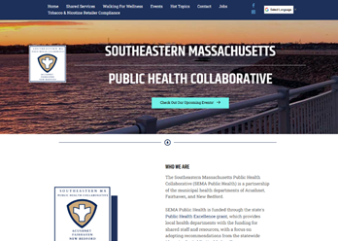 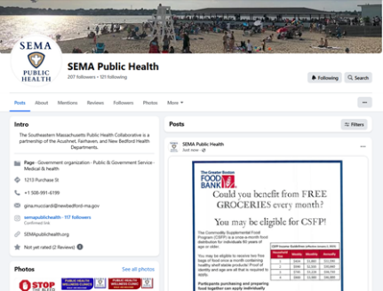
www.semapublichealth.org SEMA Public Health Facebook Page

Conclusion
The SEMA Public Health partnership has established nursing services where none previously existed and offers a myriad of services that promote health and prevent harm. A shared environmental health inspector provides needed support, backup, and language capacity for environmental health inspections, and the shared services coordinator/data analyst keeps the work driving forward by identifying gaps and coordinating needed services.
In the first half of fiscal year 2026, SEMA Public Health:
- Brought resources and health information to 2,205 people at 26 community events
- Hosted 57 clinics, providing tuberculosis skin testing, blood pressure screenings, flu vaccines, Narcan, and health education to 346 people
- Provided lifesaving skills training to 122 people
- Distributed and installed 64 car seats to families in need and provided an additional 13 car seat safety checks
- Vaccinated 262 adults for influenza, including 41 homebound adults
- Provided direct community access to SPF 30 sunscreen at 17 recreational sites during summer
- Collaborated with 39 community partner organizations to provide services
- Launched a multilingual mass media campaign
- Increased the capacity for Acushnet and Fairhaven to conduct food safety inspections
- Provided expert-level training and mentorship for three new municipal health inspectors
- Provided food safety education for restaurant staff facing repeated violations

SEMA Public Health team works in tandem with municipal health leadership and community partners to strengthen local public health service delivery in Acushnet, Fairhaven, and New Bedford efficiently and effectively health equity without utilizing municipal budgets and local taxpayer dollars.
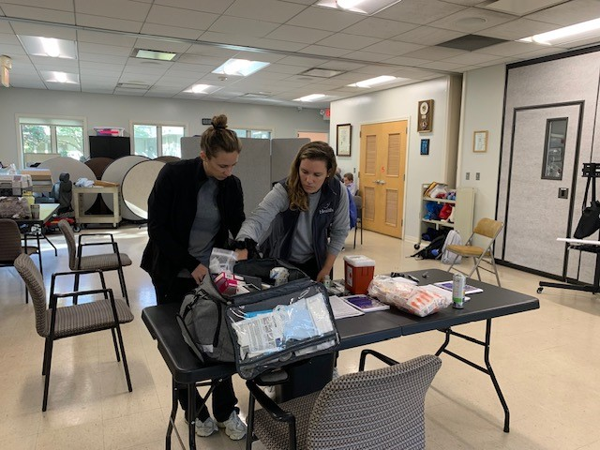

Appendix A: Staffing Chart
Staff Name & Title | FTE | Responsibilities
Gina Mucciardi, MPH  Shared Services Coordinator  & Data Analyst | 1.0 | Provide data-driven recommendations and support the design and implementation of program initiatives and special projects to improve health outcomes; Coordinate, promote, track, and report on shared public health services and staff time; Convene regular meetings with municipal public health department leads and staff to advance the goals of the grant program; Support management of the grant budget; Conduct community outreach; Disseminate health communication messaging and manage the SEMA Public Health website and social media.
Kristy MacMillen, BSN, RN, CLC  PHE Nurse | 1.0 | Support the design and implementation of program initiatives and special projects to improve health outcomes; Conduct trainings including Heartsaver CPR & AED, Narcan, Stop the Bleed, and Safe Start baby safety classes; Provide blood pressure screenings, tuberculosis skin tests, and car seat safety checks; Administer vaccines for home-bound individuals and at community clinics; Conduct community outreach; Create health messaging to be used in health communication initiatives; Provide case management for individuals with active tuberculosis (TB) and conduct backup infectious disease case investigation via MAVEN as necessary; Certified Lactation Counselor (CLC) and a Diabetes Prevention Program provider.
Ashley Correia, BSN, RN  PHE Nurse | 1.0 | Support the design and implementation of program initiatives and special projects to improve health outcomes; Conduct trainings including Heartsaver CPR & AED, Narcan, Stop the Bleed, Mental Health First Aid, and Safe Start baby safety classes; Provide blood pressure screenings, tuberculosis skin tests, and car seat safety checks; Administer vaccines for home-bound individuals and at community clinics; Conduct community outreach; Create health messaging to be used in health communication initiatives; Provide case management for individuals with active tuberculosis (TB) and conduct backup infectious disease case investigation via MAVEN as necessary.
Sofia DaCosta, RS  PHE Inspector | 1.0 | Acushnet & Fairhaven: Conduct environmental health inspections; standardize forms and processes; train new municipal staff; prepare regulations for presentation to respective boards of health; conduct risk-mitigation education outreach.  New Bedford: Assist with internal operations including process improvements and SOP creation, standardization of forms, and technology support for OpenGov; Train new employees.
Rosa Matos, CCHW  Community Health Worker | 0.25 | Acushnet & Fairhaven: Conduct community outreach; Provide car seat safety checks and blood pressure screenings.  New Bedford: Monitor MAVEN and conduct infectious disease case investigations as necessary ; Provide Directly Observed Therapy (DOT) for patients with active tuberculosis; Conduct community outreach; Provide car seat safety checks and blood pressure screenings.

Appendix B: Community Partners
During Q1 & Q2, SEMA Public Health collaborated with 39 community partners:
- New Bedford Health Department
- Acushnet Board of Health
- Fairhaven Health Department
- New Bedford Community Health
- Southcoast Health (including St. Luke’s Hospital and Southcoast Obstetrics & Gynecology)
- YMCA Southcoast
- Massachusetts Department of Children & Families
- United Way of Greater New Bedford
- United Way Family Resource Center
- Acushnet Council on Aging
- Fairhaven Council on Aging
- Buttonwood Senior Center
- Fairhaven Recreation Center
- Fairhaven Police Department
- Fairhaven Fire Department
- Acushnet Housing Authority
- Fairhaven Housing Authority
- Casey Miller Apartments
- Olympia Towers
- Discover Fairhaven
- Millicent Library
- New Bedford Free Public Library
- Greater New Bedford Opioid Task Force
- Fishing Partnership Support Services
- New Bedford Farmer’s Market
- New Beginnings Moms Do Care Program
- Buttonwood Park Zoo
- Massachusetts Society for the Prevention of Cruelty to Children
- Apple-Peach Festival
- Whaling City Festival
- Cape Verdean Recognition Committee of New Bedford
- St. Anthony of Padua Church
- Hand-Up Mattress Company
- Rise up for Homes
- Southeast Network of Community Health Workers
- Project Independence
- Little Explorers Day Care
- Greater New Bedford Allies for Health and Wellness
- Normandin Middle School

