Southeastern MA (SEMA) Public Health Collaborative
FY26 Q1 Impact Report
July 1, 2025 – September 30, 2025

Prepared by Gina Mucciardi, MPH
Public Health Excellence Shared Services Coordinator & Data Analyst

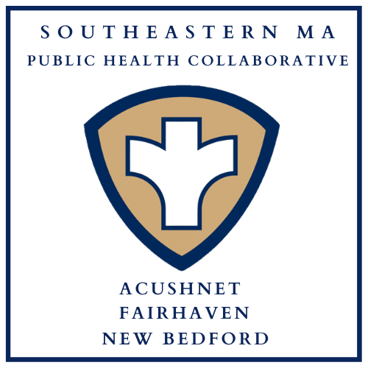

Table of Contents

Background: The Public Health Excellence (PHE) Grant Program 3
Staffing Chart 4
Public Health Nursing 5
Community Wellness, Vaccine, and Tuberculosis Clinics 5
Q1 Clinics 6
Lifesaving Skills Trainings 7
Q1 Trainings 8
Car Seat Safety Checks & Distribution Program 10
Q1 Car Seats Checked & Distributed 10
In-Home Vaccination Program 11
Q1 In-Home Vaccines 11
Infectious Disease Case Investigation 11
Tuberculosis Case Management 12
Community Outreach 12
Q1 Community Outreach 12
Blood Drives 13
2025 Blood Drives 13
Community Resources Available for Distribution 14
Sunscreen Dispensers 15
Environmental Health 16
Q1 Inspections 17
Health Communications 18
Car Seat Safety Campaign 18
Website and Social Media 19
Conclusion 20
Appendix: Community Partners 21

Background: The Public Health Excellence (PHE) Grant Program
In 2021, the New Bedford Health Department applied and was awarded grant funding by the Massachusetts Department of Public Health (MDPH) to lead a shared services arrangement comprised of Acushnet, Fairhaven, and New Bedford following the recommendations of the 2019 Blueprint for Public Health Excellence which named cross-jurisdictional sharing of public health services as an evidence-based strategy to enhance the efficiency and effectiveness of local public health in Massachusetts. These three municipalities entered into an intermunicipal agreement and became established as the Southeastern Massachusetts Public Health Collaborative, also known as SEMA Public Health.
The SEMA Public Health collaborative is now in its third year and is fully staffed with 4.25 FTE grant-funded public health professionals who facilitate and provide public health services in Acushnet, Fairhaven, and New Bedford. Currently, 91% of Massachusetts municipalities participate in the Public Health Excellence Grant Program, which funds over 270 public health workers in 56 shared services arrangements and includes a budget for supplies, training, and local travel related to public health service delivery. The goals of the PHE grant program have been codified into Massachusetts state law via the SAPHE Act of 2020, and later the SAPHE 2.0 Act of 2024. This report is intended for stakeholders in Acushnet, Fairhaven, and New Bedford and illustrates the shared benefit and impact of the Southeastern Massachusetts Public Health Collaborative.
Prior to receiving the Public Health Excellence grant award, the towns of Acushnet and Fairhaven shared one part-time public health nurse (contracted for 5 and 7 hours per week, respectively, to conduct state-mandated infectious disease case investigations via the MAVEN system); New Bedford had one full-time public health nurse (the City's Director of Public Health Nursing). To conduct environmental health inspections, Fairhaven had one health agent and one part-time health inspector, and Acushnet had one health agent who conducted all of the Town’s health inspections.
With the SEMA Public Health Collaborative, nursing services have been established where none previously existed. Two additional full-time public health nurses and a part-time community health worker now provide backup infectious disease case investigation coverage in MAVEN and a myriad of services that prevent harm and promote population health with language capacity in English and Cape Verdean Creole. Support and backup for environmental health inspections that was severely needed now exists with the hiring, onboarding, and deputization of a shared environmental health inspector with language capacity in English and Portuguese. A full-time shared services coordinator/data analyst keeps the wheels of this work turning by identifying gaps in public health service delivery and facilitating the execution of services in collaboration with municipal health leadership and community partners based on the data-driven needs of the communities. Together, this group works to level the playing field of public health service delivery in Southeastern Massachusetts, strengthening local public health protections in Acushnet, Fairhaven, and New Bedford efficiently and effectively, without utilizing municipal budgets and local taxpayer dollars.
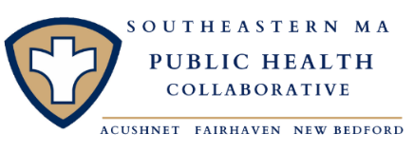

SEMA Public Health Staffing Chart
Staff Name & Title | FTE | Responsibilities
Gina Mucciardi, MPH  Shared Services Coordinator  & Data Analyst | 1.0 | Provide data-driven recommendations and support the design and implementation of program initiatives and special projects to improve health outcomes; Coordinate, promote, track, and report on shared public health services and staff time; Convene regular meetings with municipal public health department leads and staff to advance the goals of the grant program; Support management of the grant budget; Conduct community outreach; Disseminate health communication messaging and manage the SEMA Public Health website and social media.
Kristy MacMillen, BSN, RN, CLC  PHE Nurse | 1.0 | Support the design and implementation of program initiatives and special projects to improve health outcomes; Conduct trainings including Heartsaver CPR & AED, Narcan, Stop the Bleed, and Safe Start baby safety classes; Provide blood pressure screenings, tuberculosis skin tests, and car seat safety checks; Administer vaccines for home-bound individuals and at community clinics; Conduct community outreach; Create health messaging to be used in health communication initiatives; Provide case management for individuals with active tuberculosis (TB) and conduct backup infectious disease case investigation via MAVEN as necessary; Certified Lactation Counselor (CLC) and a Diabetes Prevention Program provider.
Ashley Correia, BSN, RN  PHE Nurse | 1.0 | Support the design and implementation of program initiatives and special projects to improve health outcomes; Conduct trainings including Heartsaver CPR & AED, Narcan, Stop the Bleed, Mental Health First Aid, and Safe Start baby safety classes; Provide blood pressure screenings, tuberculosis skin tests, and car seat safety checks; Administer vaccines for home-bound individuals and at community clinics; Conduct community outreach; Create health messaging to be used in health communication initiatives; Provide case management for individuals with active tuberculosis (TB) and conduct backup infectious disease case investigation via MAVEN as necessary.
Sofia DaCosta, RS  PHE Inspector | 1.0 | Acushnet & Fairhaven: Conduct environmental health inspections; standardize forms and processes; train new municipal staff; prepare regulations for presentation to respective boards of health; conduct risk-mitigation education outreach.  New Bedford: Assist with internal operations including process improvements and SOP creation, standardization of forms, and technology support for OpenGov; Train new employees.
Rosa Matos, CCHW  Community Health Worker | 0.25 | Acushnet & Fairhaven: Conduct community outreach; Provide car seat safety checks and blood pressure screenings.  New Bedford: Monitor MAVEN and conduct infectious disease case investigations as necessary ; Provide Directly Observed Therapy (DOT) for patients with active tuberculosis; Conduct community outreach; Provide car seat safety checks and blood pressure screenings.
Activities
The work of the Southeastern MA Public Health Collaborative falls into three major categories that inform the organization of this report: Public Health Nursing, Environmental Health, and Health Communications.

Public Health Nursing
The public health nursing team includes two registered nurses and one community health worker. Together, they offer clinics (wellness, vaccine, and tuberculosis skin testing), lifesaving skills trainings, car seat safety checks and distribution, in-home vaccinations, infectious disease case investigation, tuberculosis case management, and community outreach. All materials promoting these services are translated into the top three languages spoken by the communities and advertised in each municipality.

Community Wellness, Vaccine, and Tuberculosis Clinics
Three types of clinics are offered by the public health nursing division:
- Community Wellness Clinics – Launched in September 2025, our community wellness clinics include blood pressure screenings, health education, naloxone training and distribution, car seat safety checks, and community resource distribution. For the full list of community resources available for distribution by the SEMA Public Health Collaborative, see page 9.

- Vaccine Clinics – Public health nurses administer seasonal influenza (flu) vaccines (both standard and high-dose) for insured and uninsured individuals age 18 and over, as well as tetanus vaccines for uninsured individuals. In-home vaccinations are also offered, with a focus on bringing vaccines to priority populations (covered in a later section of this report). The New Bedford Health Department is also Vaccines for Children (VFC) provider and remains prepared to support childhood vaccine needs that arise.

- Tuberculosis (TB) Skin Test Clinics- Individuals may need a TB skin test for screening purposes, such as for work, school enrollment, or immigration requirements. The test involves a nurse injecting a small amount of solution just under the skin, which is then evaluated 48 hours later for a reaction. This screening helps identify latent TB infection early, so treatment can start before the disease develops and spreads to others. Weekly TB clinics are offered at the New Bedford Health Department with subsequent reporting/referral taking place for any individual with a positive skin test result.
The public health nursing team also participates in partner-sponsored wellness events. Partners include Fishing Partnership Support Services for commercial fishermen, the United Way of Greater New Bedford, and individual employers, among others.
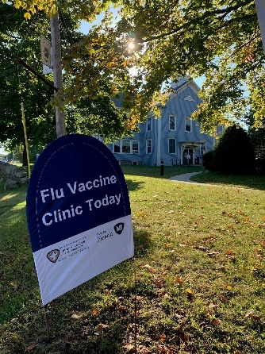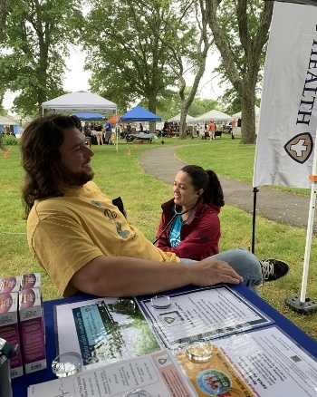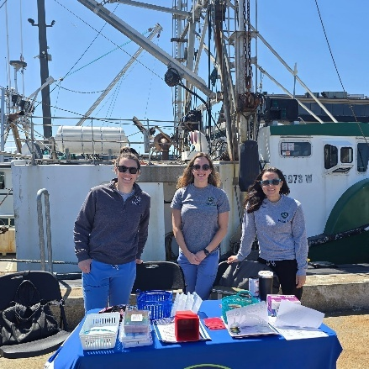

Q1 Clinics
Date | Municipality | Location | Clinic Type | Attendance
7/2/25 | New Bedford | New Bedford Health Department | TB Skin Test | 4
7/9/25 | New Bedford | New Bedford Health Department | TB Skin Test | 5
7/16/25 | New Bedford | New Bedford Health Department | TB Skin Test | 5
7/23/25 | New Bedford | New Bedford Health Department | TB Skin Test | 2
7/30/25 | New Bedford | New Bedford Health Department | TB Skin Test | 1
8/6/25 | New Bedford | New Bedford Health Department | TB Skin Test | 4
8/13/25 | New Bedford | New Bedford Health Department | TB Skin Test | 3
8/20/25 | New Bedford | New Bedford Health Department | TB Skin Test | 2
8/27/25 | New Bedford | New Bedford Health Department | TB Skin Test | 0
9/2/25 | New Bedford | Buttonwood Park Zoo | TB Skin Test | 30
9/3/25 | New Bedford | New Bedford Health Department | TB Skin Test | 0
9/10/25 | New Bedford | New Bedford Health Department | TB Skin Test | 4
9/12/25 | Fairhaven | Millicent Library | Community Wellness | 10
9/17/25 | New Bedford | New Bedford Health Department | TB Skin Test | 3
9/19/25 | Acushnet | Parting Ways Building | Flu Clinic | 6
9/19/25 | Fairhaven | Fairhaven Town Hall | Community Wellness | 3
9/22/25 | New Bedford | Steamship Pier (Fishing Partnership) | Community Wellness | 12
9/24/25 | New Bedford | New Bedford Health Department | TB Skin Test | 2
9/24/25 | New Bedford | Olympia Towers | Community Wellness | 12
9/25/25 | Fairhaven | Fairhaven Town Hall | Flu Clinic | 10
9/26/25 | Acushnet | Acushnet Council on Aging | Flu Clinic | 25
9/26/25 | New Bedford | New Bedford Health Department | Flu Clinic | 2
10/1/25 | New Bedford | Hand-Up Mattress Company | Flu Clinic | 13
10/1/25 | New Bedford | New Bedford Free Public Library – Main Branch (Downtown) | Flu Clinic | 7
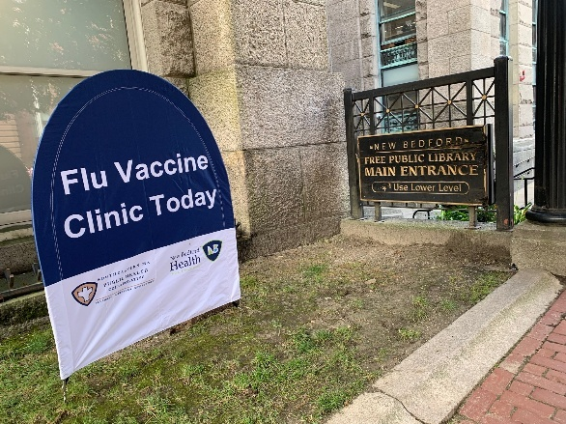 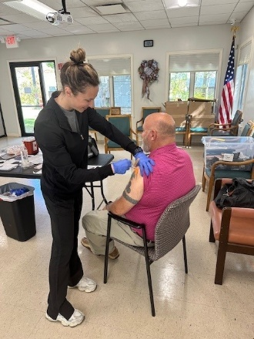
IMPACT: SEMA Public Health hosted 24 clinics in the first 3 months of this fiscal year in collaboration with 10 community partners, and provided tuberculosis skin testing, blood pressure screenings, flu vaccines, Narcan, health education, and community resources to 165 individuals across the three communities.

Lifesaving Skills Trainings
Trainings offered by the SEMA Public Health Collaborative include:
- Heartsaver CPR, AED & First Aid – Provides anyone with little or no medical training with the education to provide first aid, perform CPR, and use an automated external defibrillator (AED) for infants, children, and adults. It is a hands-on, in-person training with certification provided through the American Heart Association. Narcan (naloxone) training and distribution is included in every Heartsaver course, and organizations who complete the Heartsaver training are eligible to receive a free AED, which is made possible by another regional grant held by the New Bedford Health Department.
  - Heartsaver CPR & AED classes are held quarterly for the general public, and special classes are coordinated for target populations, including food service and recreational camp workers.
  - Heartsaver CPR & AED trainings are available year-round by request for community organizations and other groups.

- Stop the Bleed – Prepares anyone with little or no medical training to recognize and control life-threatening bleeding using proven techniques, including direct pressure, wound packing, and tourniquet application, before professional help arrives, a life-saving skill that is invaluable to any lay person, but especially relevant to the region’s marine, fishing, manufacturing, hunting, and unhoused communities.

- Safe Start Baby Safety Classes – Prepares caregivers who are expecting or who have a baby up to one year old with education about safe sleep and hands-on training for infant CPR, infant choking, and car seat safety. As Certified Lactation Counselors (CLCs), our nurses also provide lactation support to breastfeeding mothers.

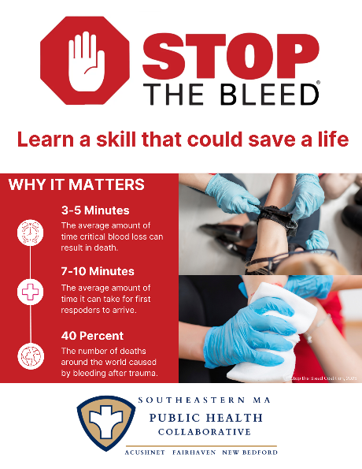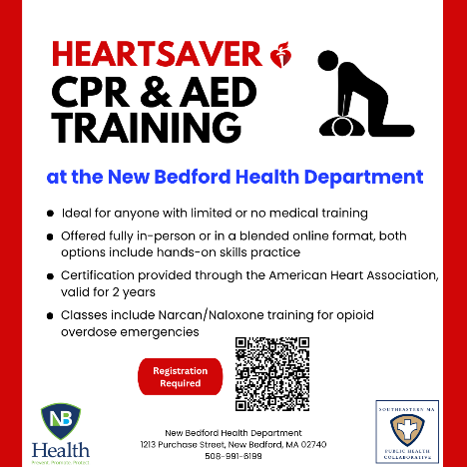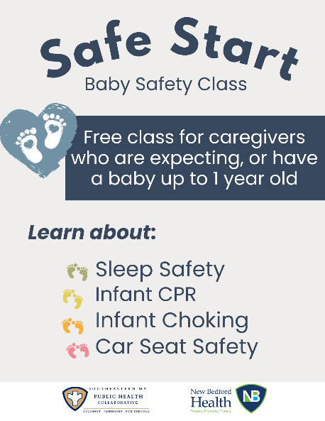

Q1 Trainings
Date | Municipality | Location | Training Type | Population | Attendance
7/22/25 | New Bedford | New Bedford Health Department | Heartsaver CPR, AED & First Aid | General public | 10
8/5/25 | New Bedford | Southcoast Health New Beginnings Moms Do Care | Safe Start | Mothers with history of substance use | 9
9/16/25 | New Bedford | New Bedford Health Department | Heartsaver CPR, AED & First Aid | Foster parents | 8
9/29/25 | New Bedford | New Bedford Health Department | Heartsaver CPR, AED & First Aid | Restaurant employees | 12

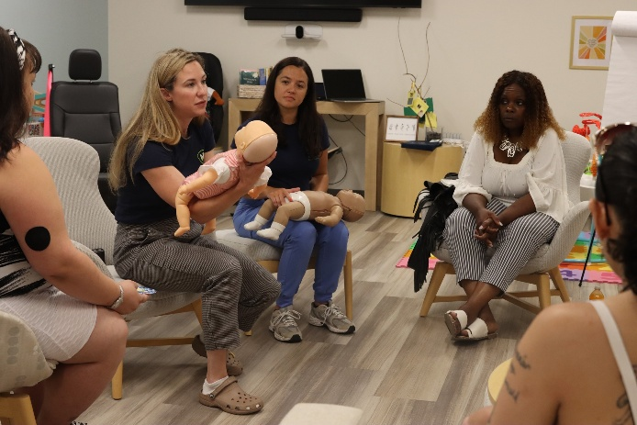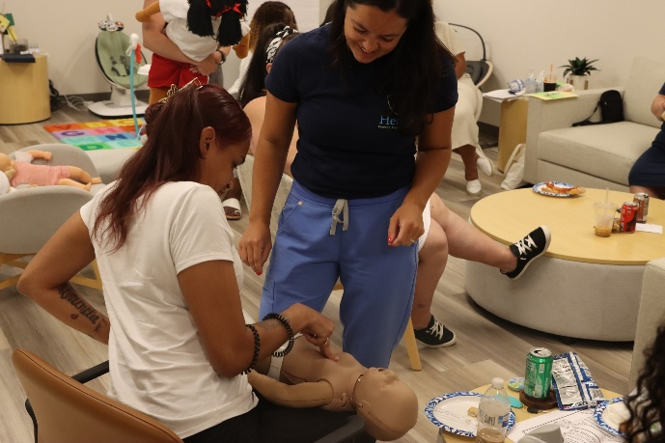
IMPACT: SEMA’s public health nurses provided lifesaving skills training to 39 individuals across several different target populations, including restaurant employees, foster parents, and new mothers with a history of substance use, in addition to the general public.

Car Seat Safety Checks & Distribution Program
Three SEMA Public Health team members (nurses and community health worker) are certified Child Passenger Safety technicians with the National Highway Traffic Safety Administration (NHTSA). This certification allows them to provide hands-on, educational car seat safety checks to ensure proper use, including installation, fit, adherence to state and national safety standards, and check for recalls.
The New Bedford Health Department is a recipient of the Massachusetts Child Passenger Safety Education and Assistance grant program, which helps provide car seats to low-income families in the region. A state supply of car seats is awarded to the New Bedford Health Department which are made available to individuals who demonstrate need and aims to ensure that low-income families are equipped with the correct car seat and caregivers are educated on proper installation and usage. The public health nursing team regularly receives referrals for car seats for area residents from St. Luke’s Hospital, Southcoast OB GYN, Massachusetts Department of Children and Families Services, New Bedford Community Health, and local early intervention providers.

Q1 Car Seat Checks Performed & Car Seats Distributed
Quarter | Safety Checks | Car Seats Distributed
Q1 (7/1/25 - 9/30/25) | 35 | 31

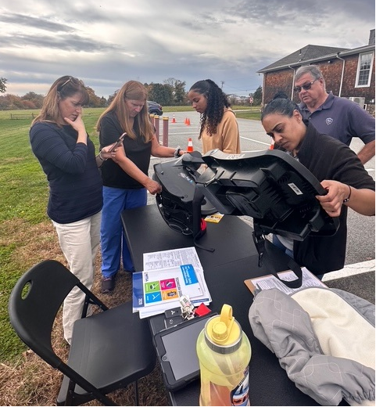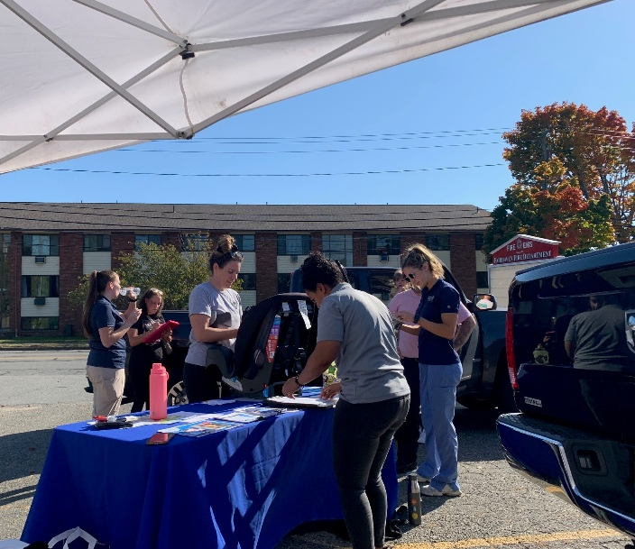

IMPACT: Car seat safety programs significantly impact child safety by preventing deaths and injuries. Thirty-one families who were unable to purchase an appropriate car seat or had an expired car seat for their child received a car seat from this program during Q1. For each, SEMA Public Health staff personally installed the seat in the family’s car and provided education on safe usage. The SEMA Public Health nursing team checked an additional 4 car seats owned and installed by community members for proper installation, fit, and usage, and provided education to caregivers during this quarter.

In-Home Vaccination Program
Each fall and winter, the public health nursing team advertises and offers no-cost, in-home flu vaccinations for adults age 18 and over in New Bedford, Fairhaven, and Acushnet who may otherwise have difficulty getting to a community vaccination clinic. SEMA Public Health’s in-home vaccine program is now in its fourth year.

Q1 In-Home Vaccines Administered
Quarter | In-Home Flu Vaccinations
Q1 (7/1/25 - 9/30/25) | 20

Impact: Flu vaccines are particularly effective for protecting vulnerable populations from influenza and its complications. Twenty homebound individuals, mostly elderly, were able to receive flu vaccines in their Acushnet, Fairhaven, and New Bedford homes by a public health nurse during this quarter.
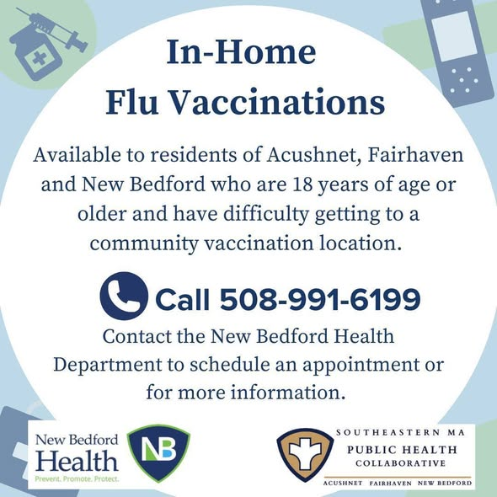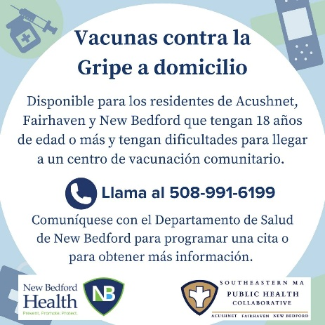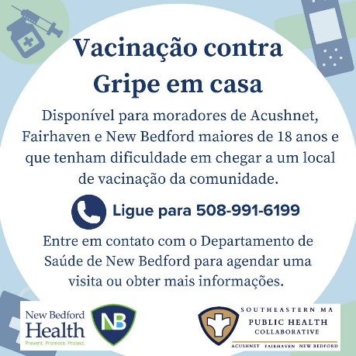

Infectious Disease Case Investigation
The SEMA Public Health nursing team provides daily monitoring of the Massachusetts Virtual Epidemiological Network (MAVEN) in New Bedford and provides backup coverage in Acushnet and Fairhaven. MAVEN is the state’s online system that directly receives communicable disease results from testing laboratories and allows the public health personnel to conduct timely case investigation for communicable diseases requiring immediate follow-up. Follow-up takes many forms, including phone calls to patients to discuss symptoms, food and travel history, talking to the health clinician who ordered the test, and working with the local Board of Health to conduct follow-up food inspections and restrict food employees. The nursing team reports out on epidemiological trends in MAVEN cases on a monthly basis at SEMA Public Health advisory board meetings. Infectious disease case investigation is mandated by state law in the Massachusetts Code of Regulations 105 CMR 300.
IMPACT: Daily MAVEN coverage allows public health professionals to address cases of infectious disease that are at high-risk for spread in order to identify the source and reduce spread of infection.

Tuberculosis Case Management
SMEA Public Health’s registered nurses provide tuberculosis case management for individuals with active cases of the disease in New Bedford and backup case management in Acushnet and Fairhaven. Tuberculosis (TB) is a highly contagious disease that primarily affects the lungs. It is usually treated with antibiotics and can be fatal without treatment. In Massachusetts, all persons with confirmed or clinically suspected TB must have a nurse case manager designated by the local board of health who works in consultation with the state’s Tuberculosis Program to ensure that an appropriate medical treatment plan is in place. Tuberculosis mase management is mandated by state law in the Massachusetts Code of Regulations 105 CMR 365.
IMPACT: Tuberculosis case management ensures that patients receive the appropriate evaluations and therapies, reduces the risk of disease spread, and improves the health outcomes of patients with active TB.

Community Outreach
Public health community outreach involves bringing education and resources directly to communities to improve overall population health; it aims to empower individuals with the knowledge and resources to take control of their wellbeing and is often done in partnership with other community-serving organizations. In the table below, ‘Touchpoints’ the approximate number of individual engagements made by the SEMA Public Health staff at each event.

Q1 Community Outreach
Date | Municipality | Event | Touchpoints
7/5/25 | New Bedford | Cape Verdean Independence Day Celebration | 65
7/11/25 | New Bedford | Whaling City Festival | 50
7/17/25 | New Bedford | Food Pantry at St. Anthony of Padua Parish | 100
7/17/25 | New Bedford | United Way Mobile Food Market (Food Pantry) at BankFive County Street | 50
7/24/25 | New Bedford | New Bedford Farmer’s Market at Buttonwood Park | 20
8/5/25 | New Bedford | National Night Out at Ashley Park | 200
8/7/25 | New Bedford | New Bedford Farmer’s Market at Buttonwood Park | 50
8/9/25 | New Bedford | We Care Community Health Fare at New Bedford Community Health | 500
8/14/25 | New Bedford | Sailing into Kindergarten at Buttonwood Park Zoo | 100
8/14/25 | New Bedford | United Way Mobile Food Market (Food Pantry) at BankFive County Street | 20
8/23/25 | Fairhaven | Huttleston HarborFest at Fort Phoenix | 100
8/26/25 | New Bedford | Overdose Awareness Day at Custom House Square | 175
9/6/25 | Acushnet | Apple-Peach Festival | 200
9/6/25 | New Bedford | United Way Wellness Day at Fort Taber | 10
9/10/25 | New Bedford | Suicide Awareness Day at River’s End Park | 150
9/22/25 | New Bedford | TLC for Two: Expecting Moms Pampering Hour at the United Way Family Resource Center | 8

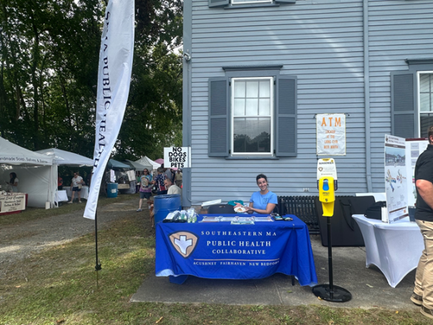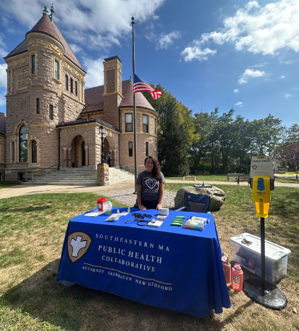
Apple-Peach Festival, Acushnet Millicent Library, Fairhaven
IMPACT: The SEMA Public Health team brought education and resources, interacting with 1,798 people at 16 community events across Acushnet, Fairhaven, and New Bedford between July 1st and September 30th of this year.

Blood Drives
This year, for the first time, SEMA Public Health coordinated and hosted three American Red Cross blood drives in partnership with Southcoast Health at each participating municipality. At each, the Southcoast Health Community Wellness Program offered point-of-care cholesterol and blood sugar (A1C) testing for blood donors and the general public.

2025 Blood Drives
Date | Municipality | Location | Attendance
6/25/25* | New Bedford | Fort Taber Community Center | 20
7/29/25 | Acushnet | Acushnet Council on Aging | 25
9/28/25 | Fairhaven | Fairhaven Recreation Center | 20
*This blood drive occurred during Q4 of FY25
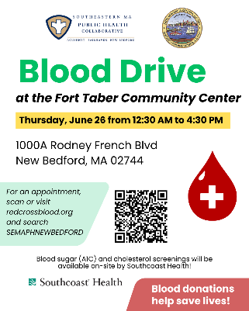 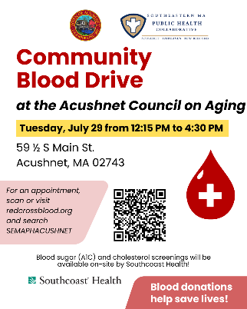 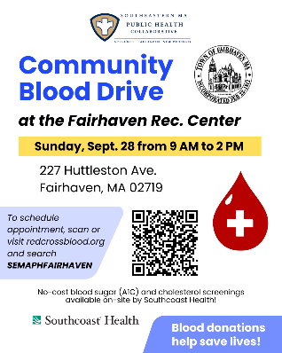
IMPACT: A total of 47 pints of blood were collected, which can make a difference to potentially 141 patients in need. At each blood drive, Southcoast Health and SEMA Public Health teams provided screenings and resources to presenting blood donors and Red Cross volunteers and staff.

Community Resources Available for Distribution
During Q1, a variety of health-promotion resources were made available for distribution at SEMA Public Health clinics, community outreach events, and at the Acushnet, Fairhaven, and New Bedford Board of Health offices. The following community resources were purchased using Public Health Excellence grant funds or donated by local organizations. Items were either branded with the SEMA Public Health logo and website or given away with a card describing the SEMA Public Health collaborative and its services:
- Tick removal kits
- Deterra drug deactivation and disposal pouches
- Medication planners (1/day, 2/day & 3/day, English & Spanish)
- Sharps containers with town-specific sharps and medication disposal information
- SPF 30 carabiner sunscreen & SPF 30 sun sticks
- SPF 30 Lip Balm
- Stop the Bleed kits
- UV400 sunglasses
- Hand sanitizer
- CPR face shields
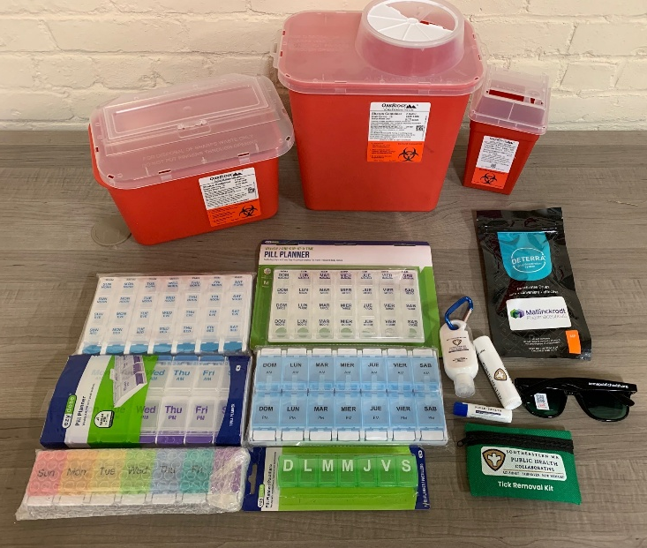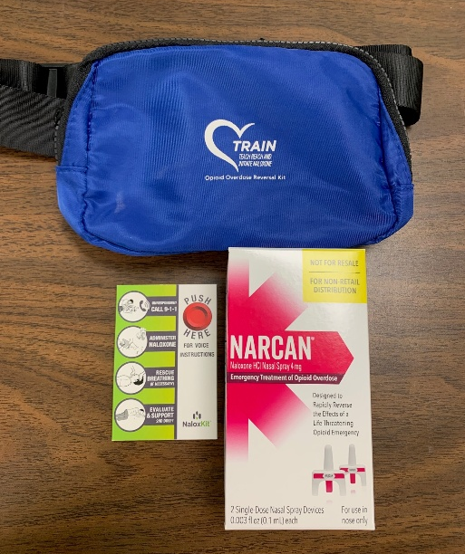
Additionally, Narcan (naloxone) kits were distributed by the SEMA Public Health nursing team to participants of Heartsaver CPR, AED, & First Aid trainings, as well as individually upon request during community outreach. Before a kit is distributed, a SEMA Public Health team member provides individualized education about recognizing and responding to an opioid overdose and how to properly administer Narcan.
Narcan kits are made available through another regional grant held by the New Bedford Health Department; The SEMA Public Health partnership has increased community access to Narcan by extending the reach of the program into Acushnet and Fairhaven.
Impact: Distributing community resources builds stronger, more resilient communities by directly giving people the tools and education to protect and improve health.

Community Sunscreen Dispensers
In 2024, SEMA Public Health purchased 17 sunscreen dispensers for public use. The sunscreen dispensers were installed once again this year during the summer months across New Bedford, Fairhaven, and Acushnet at public beaches and outdoor recreation areas and stocked with SPF 30, reef-safe, sport sunscreen. An additional mobile sunscreen dispenser unit was brought to community outreach events.

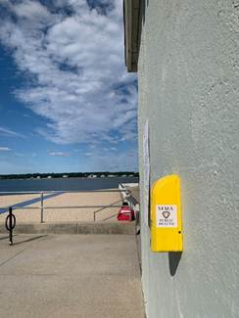 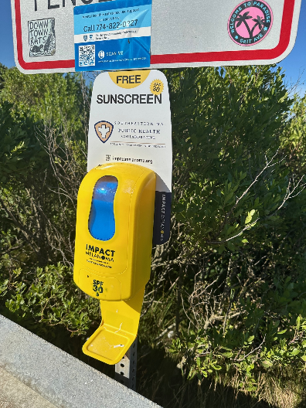 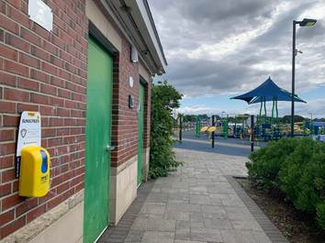West Beach, New Bedford West Island, Fairhaven Noah’s Place Playground, Pope’s Island
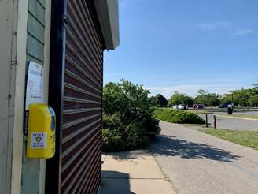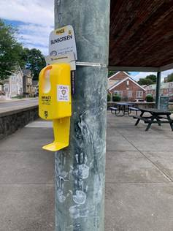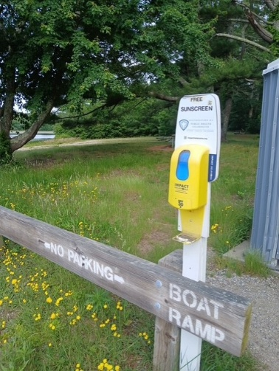
Fort Taber, New Bedford Monte Park, New Bedford Acushnet Sawmill
Impact: SEMA Public Health gave communities direct access to SPF 30 sunscreen by providing 17 sunscreen dispensers at recreation spaces across Acushnet, Fairhaven, and New Bedford during the summer months.

Environmental Health
On June 15th 2025, SEMA Public Health hired its first environmental health inspector, a bilingual Registered Sanitarian, Sofia DaCosta, who speaks both English and Portuguese. In her first months on the job before becoming onboarded and deputized to perform inspections in Acushnet and Fairhaven in September, Sofia served mainly in New Bedford, training newly hired inspectors and assisting with internal operations. Her major projects for each of the towns are as follows:
- Acushnet: Conduct food inspections and transition the town to a risk-based food inspection schedule; conduct other environmental ad-hoc inspections as needed
- Fairhaven: Conduct food inspections and transition the town to a risk-based food inspection schedule; conduct other environmental ad-hoc inspections as needed
- New Bedford: Employee training, assist with internal operations including SOP creation, process improvements, OpenGov technical support

Q1 Environmental Health Inspections
Date | Municipality | Inspection Type | Location | Hours
9/6/25 | Acushnet | Perc Test | Residential | 5
9/30/25 | Fairhaven | Food | Restaurant | 2
9/30/25 | Fairhaven | Food | Restaurant | 2

If a food establishment is facing possible shutdown due to foodborne illness risk factors in Acushnet, Fairhaven, or New Bedford, employee training may be conducted by the SEMA Public Health inspector. During Q1, the SEMA Public Health inspector conducted food safety education at one restaurant establishment for two hours.
IMPACT: A shared regional inspector provides severely needed support, backup, and language capacity for environmental public health inspections in Acushnet and Fairhaven. This increase in inspectional capacity will protect the public’s health and safety by transitioning Acushnet and Fairhaven to a risk-based food inspection schedule, so that types of food establishments with greater risk for foodborne illness outbreaks are inspected more frequently. A Registered Sanitarian (RS), the highly trained shared inspector provides high-quality training for all types of inspections to new staff and assists with process improvements in each of the three participating municipalities.
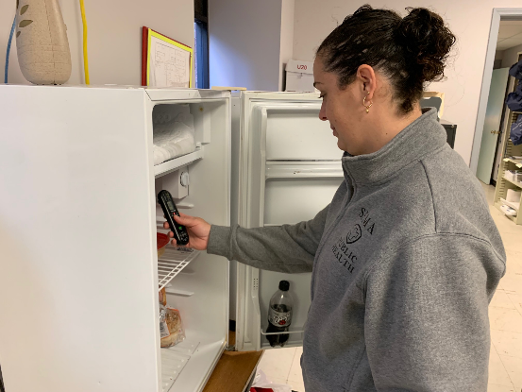

Health Communications

Car Seat Safety Campaign
During Q1, SEMA Public Health launched a major health communications campaign to promote its free car seat safety check service and increase recognition of the SEMA Public Health collaboration and branding. The campaign included a billboard on Route 195 W in New Bedford and 13 SRTA buses on the New Bedford-Fairhaven-Intercity routes in English, Spanish, and Portuguese.
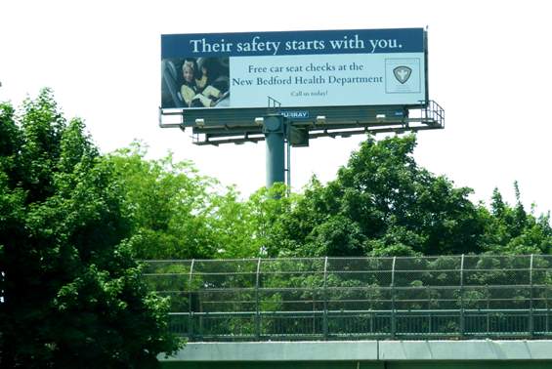
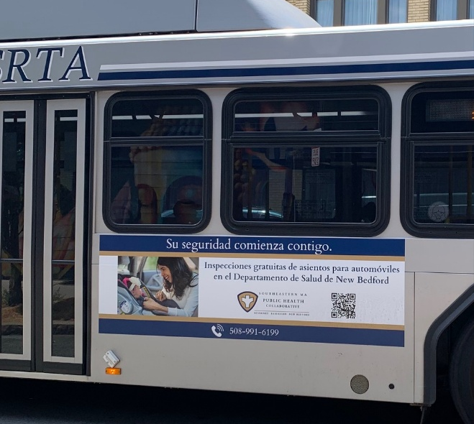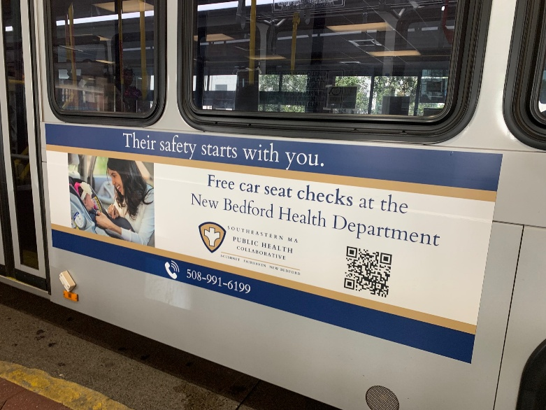
Impact: This multi-lingual mass media campaign resulted in a notable increase in phone calls for car seat safety checks and raised awareness of the public health partnership. For over two months, the billboard and buses displayed the SEMA Public Health logo with town names and branding, and the messaging was seen by thousands of people in English, Spanish, and Portuguese.

Website and Social Media
SEMA Public Health has a website, Facebook, and Instagram account that are regularly updated and monitored by the shared services coordinator. These media outlets advertise nursing services and events put on by the SEMA Public Health collaborative and its partners and share messaging that aims to promote and protect health. Occasionally, posts are ‘boosted’ on Facebook and Instagram, where the Collaborative pays to advertise content within the geographic areas of Acushnet, Fairhaven, and New Bedford to reach accounts beyond its followers.
SEMA Public Health Website
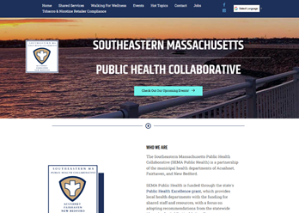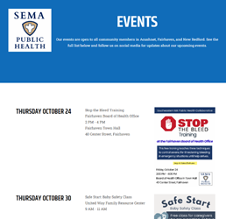
semapublichealth.org home page semapublichealth.org events page
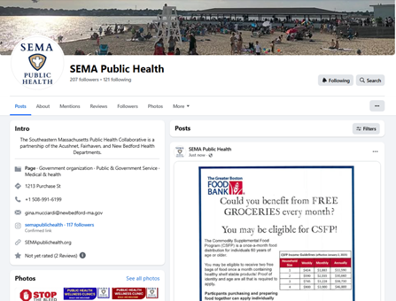
SEMA Public Health Facebook Page
Impact: During Q1, SEMA Public Health created and shared 83 posts related to its public health services, resources, and health promotion topics, which were viewed by thousands of local accounts.

Conclusion
The SEMA Public Health partnership has established nursing services where none previously existed, offering a myriad of services that prevent harm and promote health. A shared environmental health inspector provides needed support, backup, and language capacity for environmental health inspections, and the shared services coordinator/data analyst keeps the work driving forward by identifying gaps and coordinating needed services.
In the first quarter of the fiscal year alone, they:
- Brought resources and health information to 1,798 people at 16 community events
- Hosted 24 clinics, providing tuberculosis skin testing, blood pressure screenings, flu vaccines, Narcan, health education, and community resources to 165 individuals
- Provided lifesaving skills training to 39 individuals across target populations
- Educated 35 caregivers on car seat safety and distributed 31 car seats to families in need
- Vaccinated 20 homebound individuals
- Provided direct community access to SPF 30 sunscreen at 17 recreational sites via the installation and maintenance of sunscreen dispensers
- Strengthened community partnerships by working together with 29 community agencies
- Launched a multilingual mass media campaign that increased awareness of the partnership and its services
- Conducted 3 environmental health inspections and finalized plans for increasing food inspections in Acushnet and Fairhaven
- Provided ongoing training for three new municipal inspectors
- Provided food safety education for restaurant employees
Together, this group works in tandem with municipal health leadership and community partners to strengthen local public health service delivery in Acushnet, Fairhaven, and New Bedford efficiently and effectively, advancing racial and health equity without utilizing municipal budgets and local taxpayer dollars.
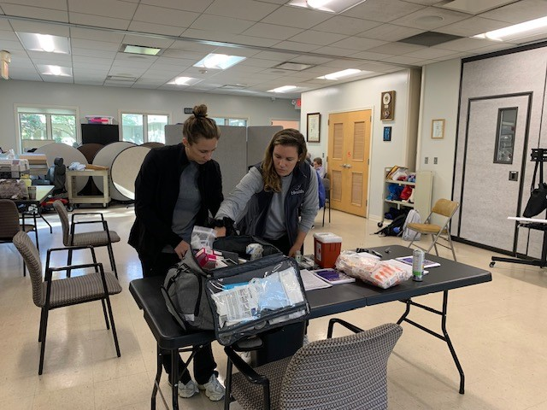

Appendix
Community Partners
During Q1, SEMA Public Health supported or worked with 29 community partners:
- New Bedford Health Department
- Acushnet Board of Health
- Fairhaven Health Department
- Southcoast Health (including St. Luke’s Hospital and Southcoast Obstetrics & Gynecology)
- YMCA Southcoast
- Massachusetts Department of Children & Families
- United Way of Greater New Bedford
- United Way Family Resource Center
- Acushnet Council on Aging
- Fairhaven Recreation Center
- Fairhaven Fire Department
- Fairhaven Housing Authority
- New Bedford Community Health
- Discover Fairhaven
- Millicent Library
- Greater New Bedford Opioid Task Force
- Fishing Partnership Support Services
- New Bedford Farmer’s Market
- New Beginnings Moms Do Care
- Buttonwood Park Zoo
- Massachusetts Society for the Prevention of Cruelty to Children
- New Bedford Free Public Library Main Branch
- Apple-Peach Festival
- Whaling City Festival
- Cape Verdean Recognition Committee of New Bedford
- St. Anthony of Padua Church
- Hand-Up Mattress Company
- Kacey Miller Apartments
- Olympia Towers

